Sports Underdog PSMT – Eden Tomes

# Introduction:

Stories of unexpected underdog triumphs hold a significant place in competitive sports culture, with their occurrence causing commotion amongst fans of winning and losing teams alike. A prevailing argument from resentful fans speculates that weaker teams have a higher likelihood of success in shorter competitions due to reduced opportunities for the stronger team to assert dominance. This report investigates the validity of this claim by analysing how the length of an NBA playoff series impacts a below-average team’s odds of winning, comparing the success rate for a 7-game, 5-game, and 3-game series. By comparing and analysing success rates across these differing series formats, this study aims to quantify the relationship between series length and underdog performance, providing insights into tournament design and competitive fairness.

# Observations:

* Different sports competitions have varying numbers of rounds, which is significant because it provides the basis for investigating whether more rounds affect a weaker team’s chance of winning.
* Examples like Emma Raducanu and Morocco’s World Cup run demonstrate that underdogs do occasionally succeed in high-profile competitions. This is important because it provides real-world examples that support or contradict the claim being investigated.
* There appears to be general interest in whether competition structures provide fair opportunities for all participants, especially underdogs, establishing the relevance of the investigation.

# Assumptions:

* To test whether weaker teams have better chances in competitions with fewer rounds, it is assumed that a team’s “strength” can be measured/defined by their winning percentage. This is significant because the entire claim hinges on being able to identify which teams are “weaker”.
* It is assumed that a mathematical probability model that simulates each game independently can accurately represent the outcomes of sporting competitions, despite not considering outside factors that affect a team’s performance (home-court advantage, fatigue, coaching adjustments, team morale, momentum, pressure). This allows the claim to be better tested and analysed using statistical methods.
* It is assumed that—in addition to the tangible skill difference between teams—there is some element of randomness or chance that has an influence on sporting outcomes. This is significant because without this assumption, stronger teams would always win regardless of the number of rounds.
* It is assumed that increasing the number of rounds reduces the relative impact of randomness and allows a difference in ability to more substantially dictate the outcome. This is a key assumption that directly relates to testing the claim surrounding underdog victories.
* It is assumed that the chosen real-world data (regular season record of the 2024-2025 Chicago Bulls, as of 15/02/2025) is representative of the typical underdog team. This is crucial, as it ensures the results of the simulation model are meaningful in evaluating the relationship between competition format and outcomes.

# Method:

To investigate the impact of series length on underdog success, a probabilistic simulation model was developed using Microsoft Excel. The NBA Chicago Bulls’ 2024-25 regular season win rate of 0.400 (*Basketball-Reference.com*, 2025) served as the underdog’s probability of winning any single game. Three series formats were analysed: 7-game (first to 4 wins), 5-game (first to 3 wins), and 3-game (first to 2 wins).

## Simulation Setup:

For each series length, 1000 independent trials were conducted. Each game outcome was determined using Excel’s =RAND() function. A value below 0.4 recorded an underdog win; otherwise, a loss. The series concluded once the underdog or opponent achieved the required number of wins (e.g. 4 games in a 7-game series).

## Data Collection:

The total series wins by the underdog were recorded for each format. The percentages of trials won were calculated as:

$$\text{Win} \text{Percentage}=\frac{\text{Number} \text{of} \text{Series} \text{Won}}{\text{Total} \text{Trials}\text{ (1000)}}×1000$$

## Theoretical Comparison:

Binomial probability formulas were applied to compute the theoretical probability of the underdog winning each series type. For a best-of- $$n$$ series:

$$P\left(\text{Win}\right)=\sum_{k=\left\lceil n/2\right\rceil }^{n}{\left({n \atop k}\right){\left(0.4\right)}^{k}{\left(0.6\right)}^{n−k}}$$

This provided a benchmark to validate the simulation results.

# Results:

(Figure 1 – Results Table)

|  |  |  |  |
| --- | --- | --- | --- |
| **Series Length:** | **Calculated Binomial (Theoretical) Probability:** | **Trials Won by Weaker Team (out of 1000):** | **Percentage of**  **Trials Won:** |
| 7-game (first to 4) | 28.98% | 307 | 30.70% |
| 5-game (first to 3) | 31.74% | 327 | 32.70% |
| 3-game (first to 2) | 35.20% | 377 | 37.70% |

(Figure 2 – Bar Graph: Num. Of Series Won by Type)

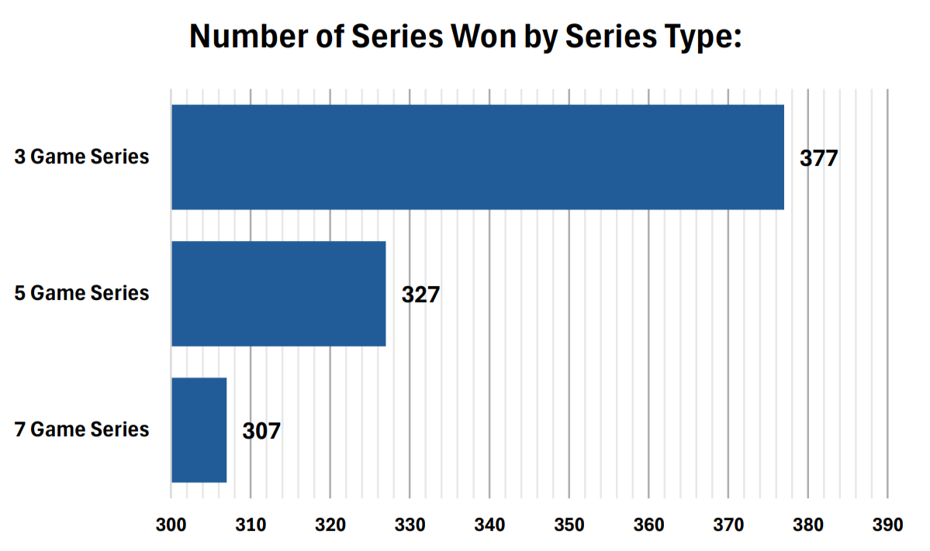

(Figure 3 - Line Graph: Series Length vs % Of Series Won)

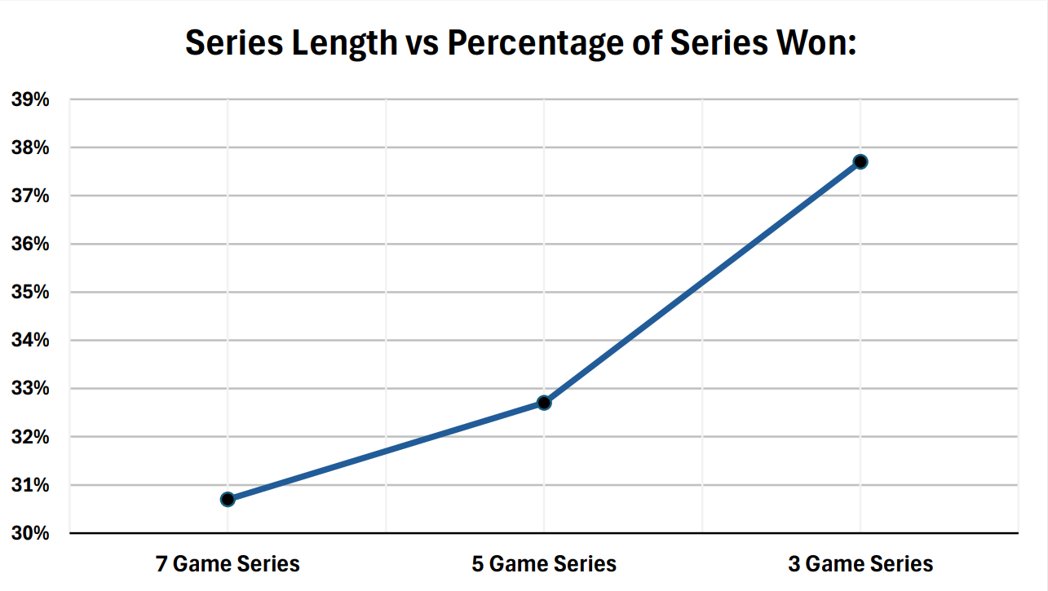

The simulation results presented in figure 1 clearly show that as the series length decreases, the underdog’s win rate increases. In the 7-game series, the weaker team wins about 30.70% of the trials, whereas in the 3-game series, the win rate rises to 37.70%—an increase of roughly 23% proportional to the 7-game format. The 5-game series, at 32.70%, fits neatly between these two extremes, indicating that even a reduction by 1-2 games can improve the underdog's performance. This trend supports the prediction that shorter competitions, with their higher variance, offer underdogs a better opportunity to capitalize on the inherent randomness of a small number of games.

Figure 2’s bar graph visually reinforces the numerical data by clearly displaying the difference in the number of series wins for each format, with distinct bars for each series length to allow direct comparison. Similarly, Figure 3’s line graph, with series length on the x-axis and win percentage on the y-axis, is composed to highlight the steadily increasing trend as the series length decreases, thus emphasizing the inverse relationship between competition length and underdog success.

The calculated binomial probabilities are in close agreement with the simulation results, deviating by no more than 2.5%, which confirms the robustness and validity of the simulation model.

# Discussion:

The trend seen in the simulation results establishes a clear and consistent inverse relationship between competition length and underdog success rates, validating the claim that shorter formats amplify the effect of randomness. This relationship is evidenced by the 23% proportional increase in victory rates from 7-game (30.7%) to 3-game (37.7%) formats. This progression aligns with theoretical expectations, as it was speculated that fewer games elevate variance and allow weaker teams to exploit randomness in outcomes. The visual representations reinforce this by graphically illustrating the decline in underdog victories as series length increases, emphasizing the inverse correlation between competition length and unpredictability.

Collectively, these findings confirm that shorter competitions do enhance underdog opportunities by magnifying the role of chance in victory, while extended formats favour consistently high skill. This dynamic gives a critical understanding of the balance between fairness and unpredictability in competitive structures.

# Critique:

## Strengths of Investigation

* **Alignment With Predictions:** The simulation’s results closely align with what binomial probability predicts (with deviations no more than 2.5 percentage points), confirming that the solution identified is mathematically sound.
* **Use Of Real Data:** By grounding the analysis in the fixed 40% win rate of the Chicago Bulls, the model effectively isolates the impact of series length on winning and maintains practical relevance to real-world scenarios.
* **Support From Examples:** The observed examples of real-world underdog stories like Morocco’s 2022 World Cup success and Emma Raducanu’s US Open victory empirically validate the model’s conclusion that shorter formats amplify randomness, rationalizing the identification of an inverse correlation between series length and underdog victory rates.

## Limitations of Investigation

* **Simulation Restraints:** The mathematical simulation model ignores dynamic factors like home-court advantage, player fatigue, and tactical adjustments mid-series. Other important aspects such as momentum shifts, pressure dynamics, and team morale – critical in actual competitions – are absent in the model. Real leagues commonly see shifts due to these factors affecting win rates mid-series, making the simulation results less applicable to real-life sports scenarios.
* **Static Win Probability:** The underdog’s 40% win probability for each game remains constant across all trials. However, actual team strength can vary from game to game. An analysis using multiple win rates (e.g., 30%, 50%) would test the robustness of the trend and improve generalizability.
* **Competition Structure:** The observed examples of real underdog successes occur in single-elimination tournaments, which have fundamentally different structures than series-based playoffs. In addition, real tournaments (like the NBA playoffs) often involve multi-round formats with reseeding or varying opponents, which could alter underdog trajectories. These differences suggest the conclusions drawn from this model may not be directly applicable to sports with different competitive structures.
* **Sample Size Limitations:** While 1,000 trials yield stable results, increasing simulations to 10,000+ would minimize residual variance and align empirical probabilities even closer to theoretical values, thereby strengthening the precision of the study.

# Conclusion:

This study set out with the intent of investigating a widespread debate amongst fans of competitive sports: whether shorter competition formats truly grant “underdog” teams a greater shot at victory, as many speculate. Through an analysis of NBA playoff formats (specifically comparing the outcomes of 7-game, 5-game, and 3-game series), the findings confirm that the number of games does play a critical role in the series verdict. Shorter series, like a 3-game matchup, sway the odds in favour of underdogs by allowing luck and unpredictability to shine. In contrast, longer formats such as the traditional 7-game series reward teams with consistent skill, as they have more chances to prove their dominance.

These results give insight into why underdog stories (e.g. Morocco’s 2022 World Cup success, Emma Raducanu’s US Open victory) are more prevalent in brief, high-stakes tournaments. However, they also demonstrate why competitive sports leagues, namely the NBA, prioritize longer series to ensure the "best" team consistently triumphs. For competition organizers, this creates a trade-off, as shorter formats deliver thrilling surprises for fans, while longer formats prioritize fairness.

Despite the study’s simplification of real-world factors like injuries or team momentum, it highlights that the proper adjustment of series length supports a balance between drama and fairness, a key principle for designing competitions. Future research could further investigate how other elements, like tournament rules or team dynamics, interact with this balance. Overall, one idea is made evident: in competitive sports, the length of a competition isn’t just a detail—it plays a crucial role in deciding who wins and why.

# Word Count: 1625

# Reference List:

* Basketball-Reference.com. (2025). *Basketball Statistics and History* | *Basketball-Reference.com.* [online] Available at: <https://www.basketball-reference.com/> [Accessed 15 Feb. 2025].

# Appendix:

## Excel Formulae

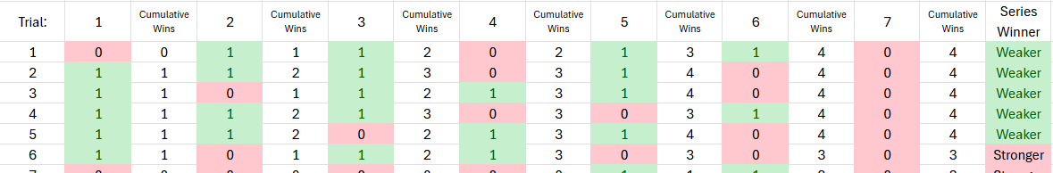

Where:

For each individual game, a 1 indicates a win, while a 0 indicates a loss.

For each series trial, a result of “Weaker” indicates an underdog victory, while a result of “Stronger” indicates an underdog loss.

* Game 1: 
* Subsequent games:   
  where V4 is the current cumulative wins and $B$2 is the number of games required to win the series
* Series winner:   
  where R4 is the final number of cumulative wins